**Assignment on Azure , Power Bi, Toad modeler**

Database: AdventuresWorksLT

1. Using the Power BI the AdventuresWorksLT database is loaded from MS Azure to Power BI

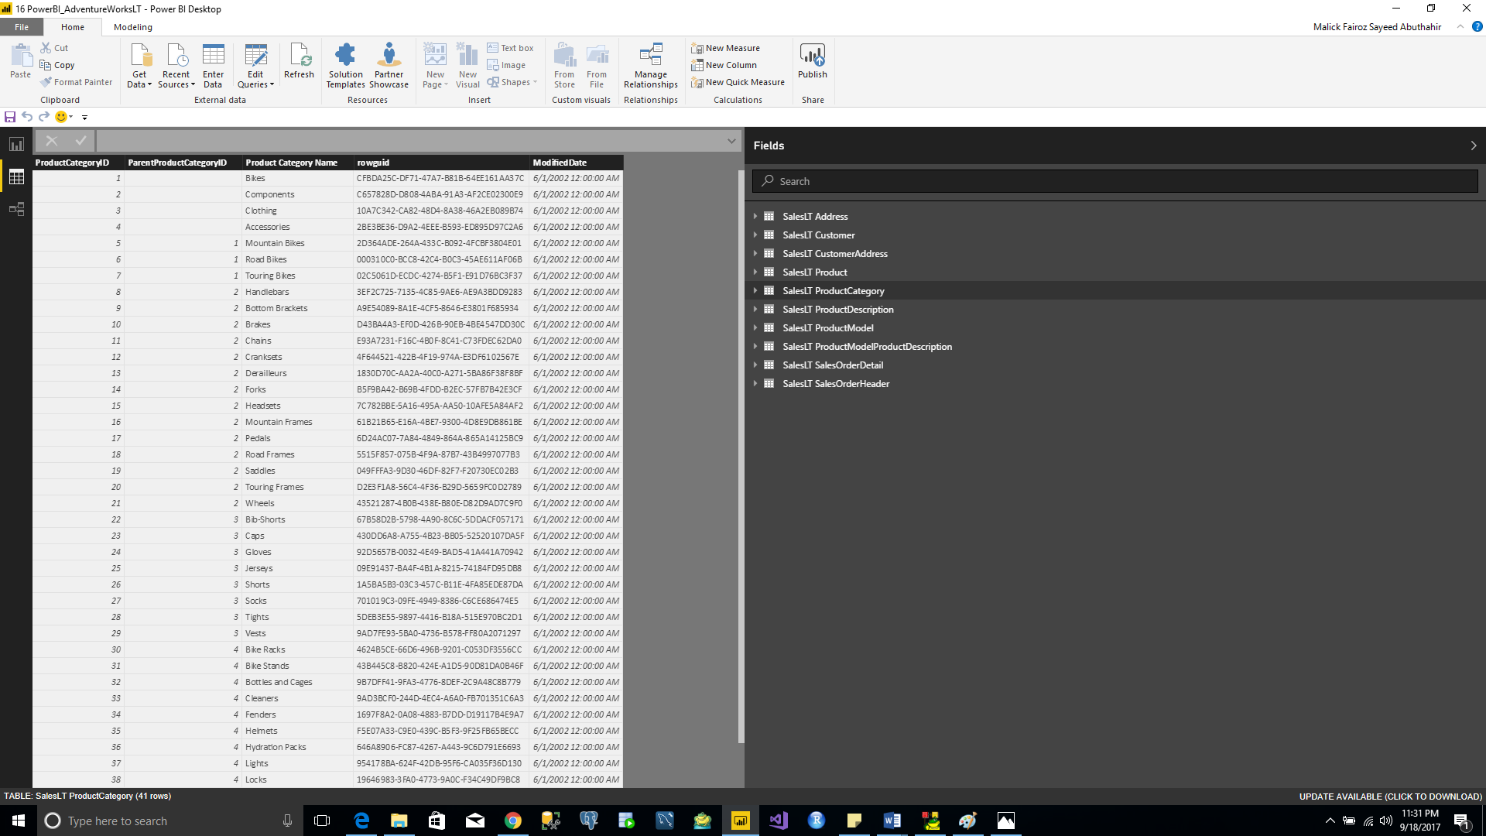

1. The Tabular report and visualization are generated for each query
2. Total Sales

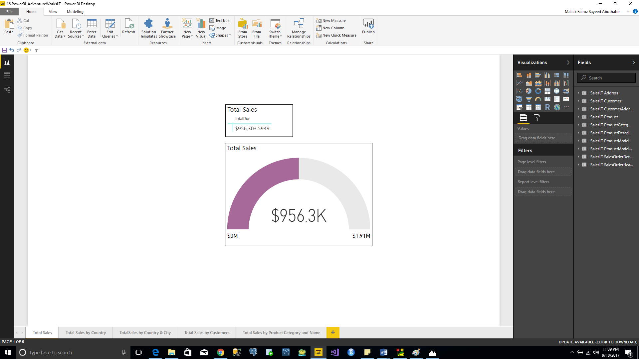

1. Total Sales by Country

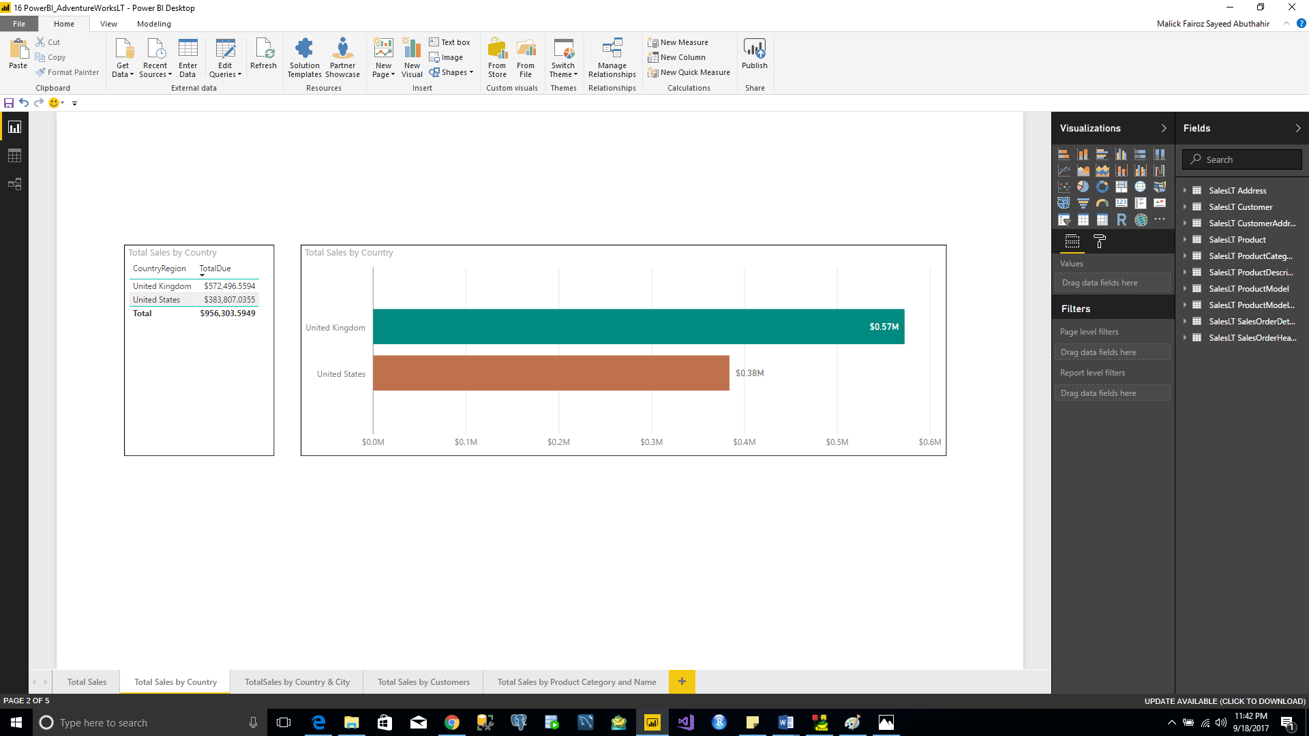

1. Total Sales by Country and City

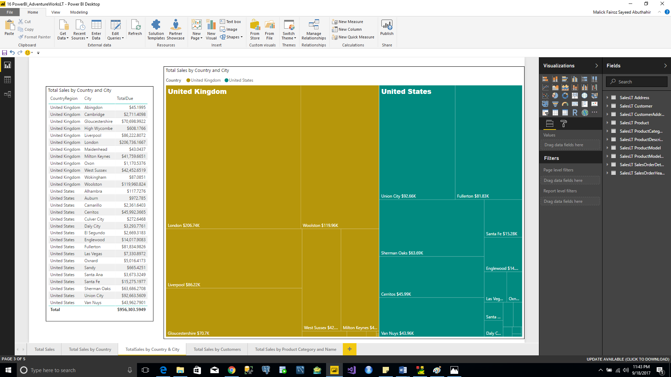

1. Total Sales by Customer

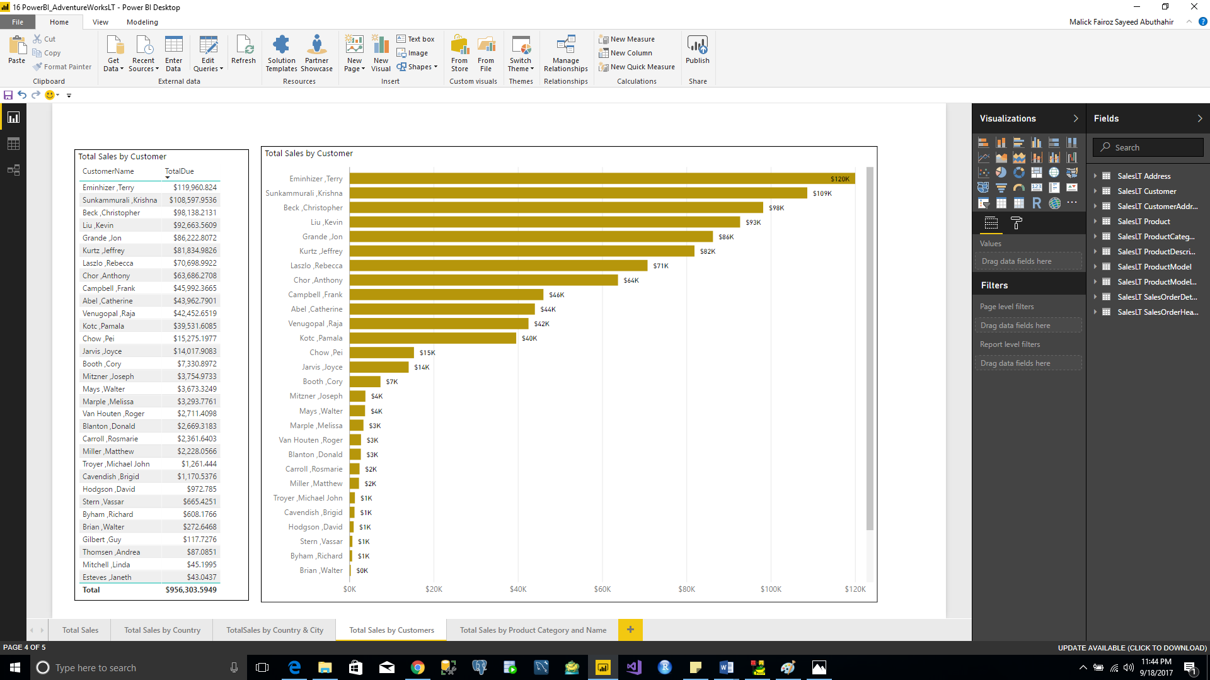

1. Total Sales by Product Category and Name

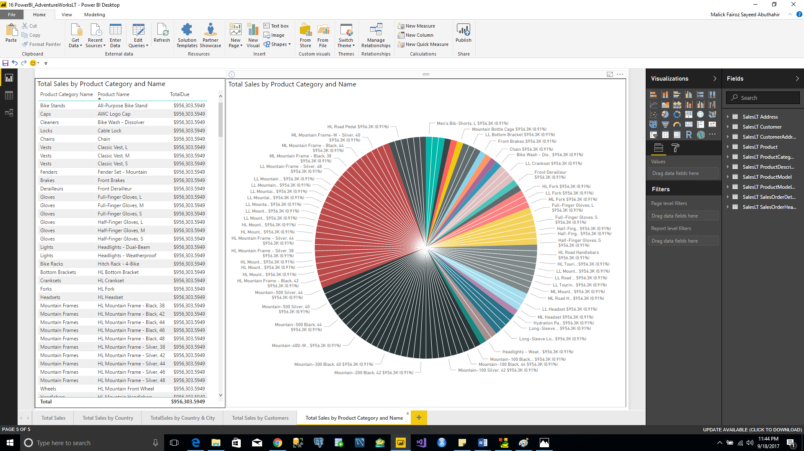

1. Reverse Engineer is done for AdventureWorksLT database from MS Azure to Toad Data Modeler

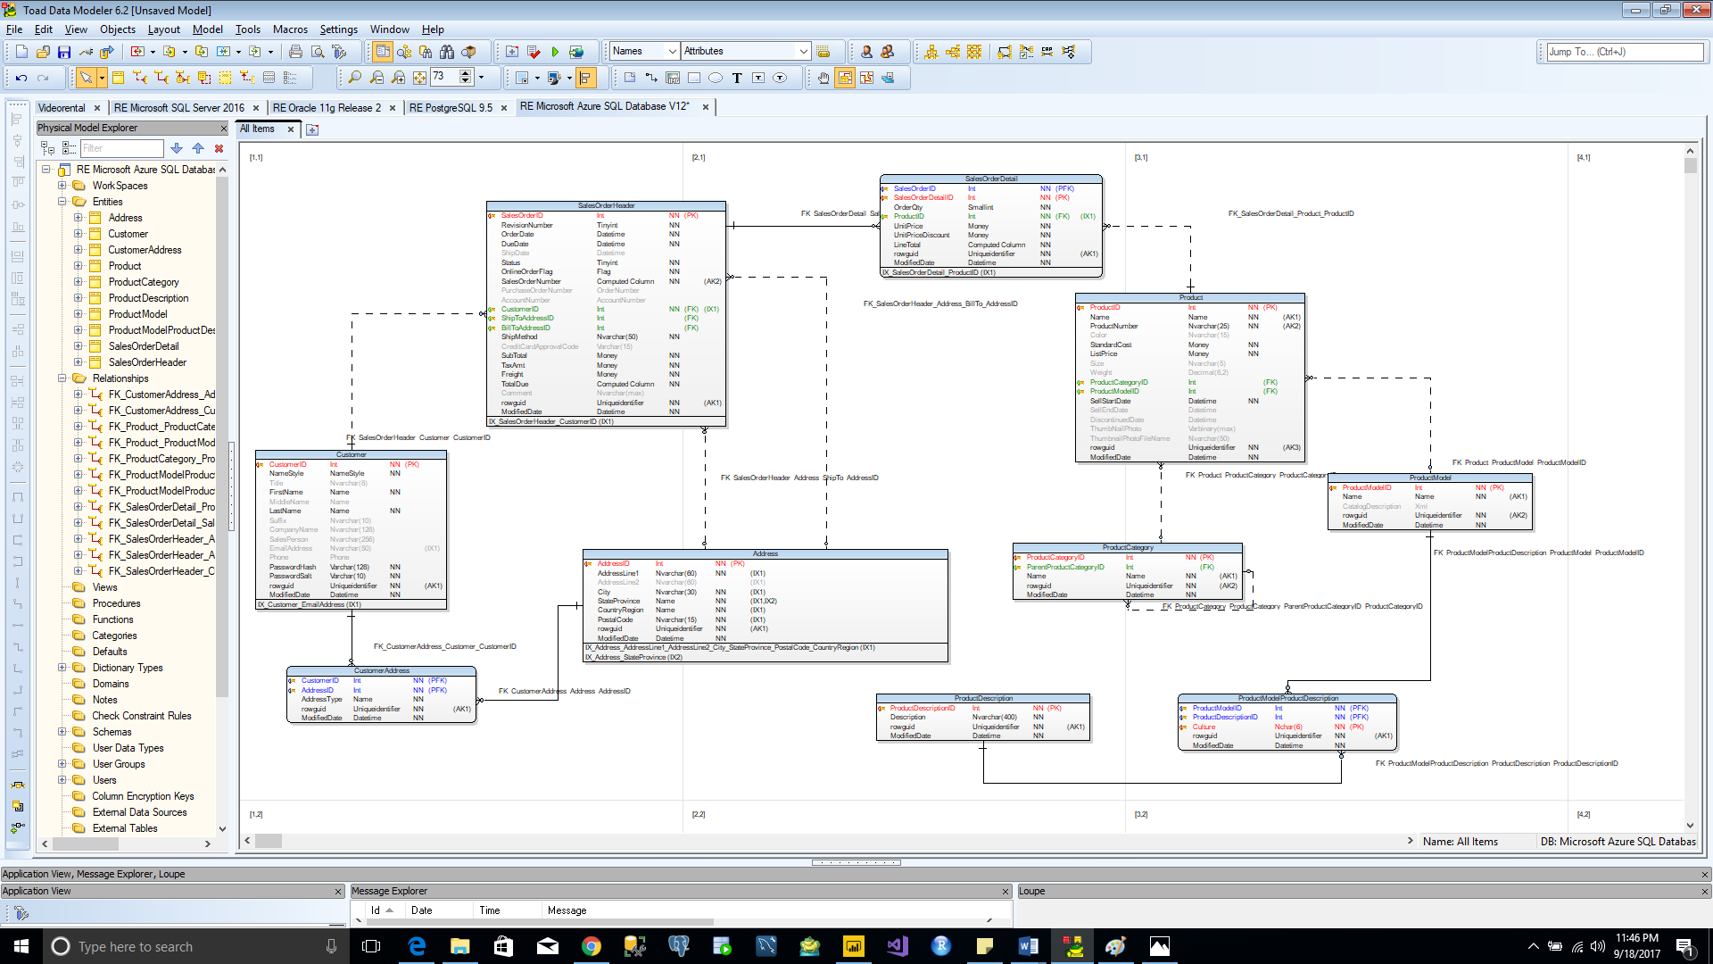

1. The ER model of AdventureWorksLT database from Power BI is shown below for the comparison with the ER model of same database from Toad Data Modeler.

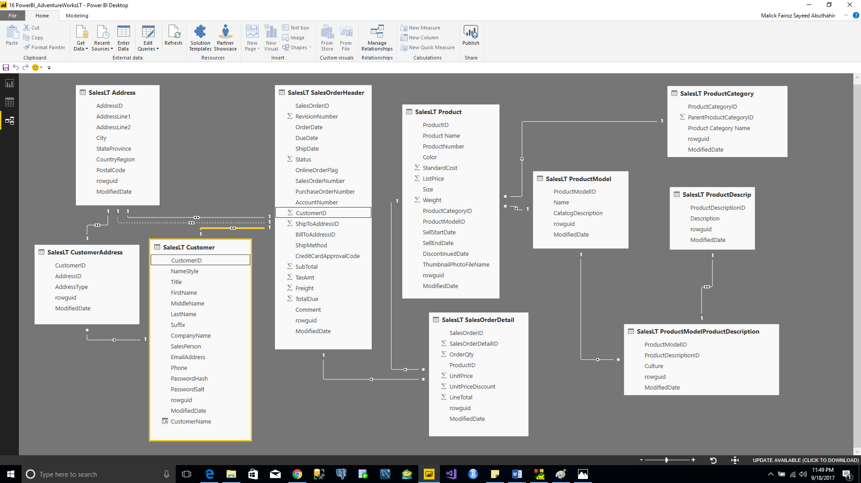

Comparison between the Toad Data Modeler and Power BI for the ER model

|  |  |  |
| --- | --- | --- |
| **SL.NO** | **Toad Data Modeler** | **Power-BI** |
| 1. | Primary key is shown on the table | Primary key is not shown |
| 2. | Foreign Keys are shown on the table | Foreign Keys are not shown |
| 3. | Referential Integrity are represented clearly for understanding including cardinality, and weak & strong entity | No proper representation |
| 4. | Column Datatypes and Null value indicator are displayed | There is no details on Column datatypes and Null value indicator |
| 5. | Indexes are displayed in the end of the table | Indexes are not displayed |
| 6. | There is no representation of the calculated columns | Calculated Value columns are displayed with Summation symbol |